HPC LAB ASSIGNMENT

●PRN: 23510029​
●Batch: B3​
●Experiment No: 1​
●Title: Introduction to HPC Environment and Shared Memory Parallel Programming
Objective: To understand the HPC environment and implement basic programs using
OpenMP.​

●​ Problem Statement: High Performance Computing (HPC) involves the use of parallel
processing techniques to solve computationally intensive problems. Study basics of
OpenMP for shared memory parallel programming using CPU threads.

Task 1
Task 1: HPC Environment Setup and System
Configuration

Parameter | Specification
Processor Model | Intel(R) Core(TM) i5-1235U (12th Gen Alder Lake)
Number of CPU Cores | 10 Cores (2 Performance-cores + 8 Efficient-cores)
Number of Logical Processors | 12 Threads
CPU Frequency | Up to 4.40 GHz Maximum Turbo Frequency
Cache Architecture | L1 Cache, L2 Cache and 12 MB Intel Smart Cache (L3)
RAM Size | As installed on the system
Operating System | Linux (Ubuntu x86_64)
SIMD Instruction Support | SSE4.1, SSE4.2, AVX2
SIMD Width | 256 bits for AVX2
Single Precision SIMD Width | 8 × 32-bit floating-point values

Screenshot:
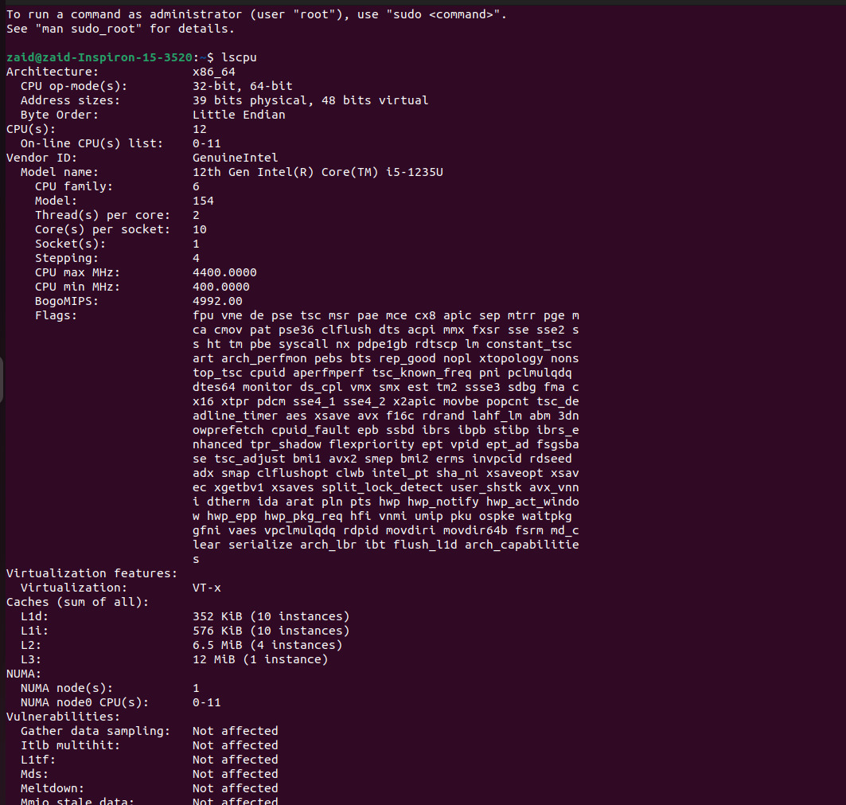
an
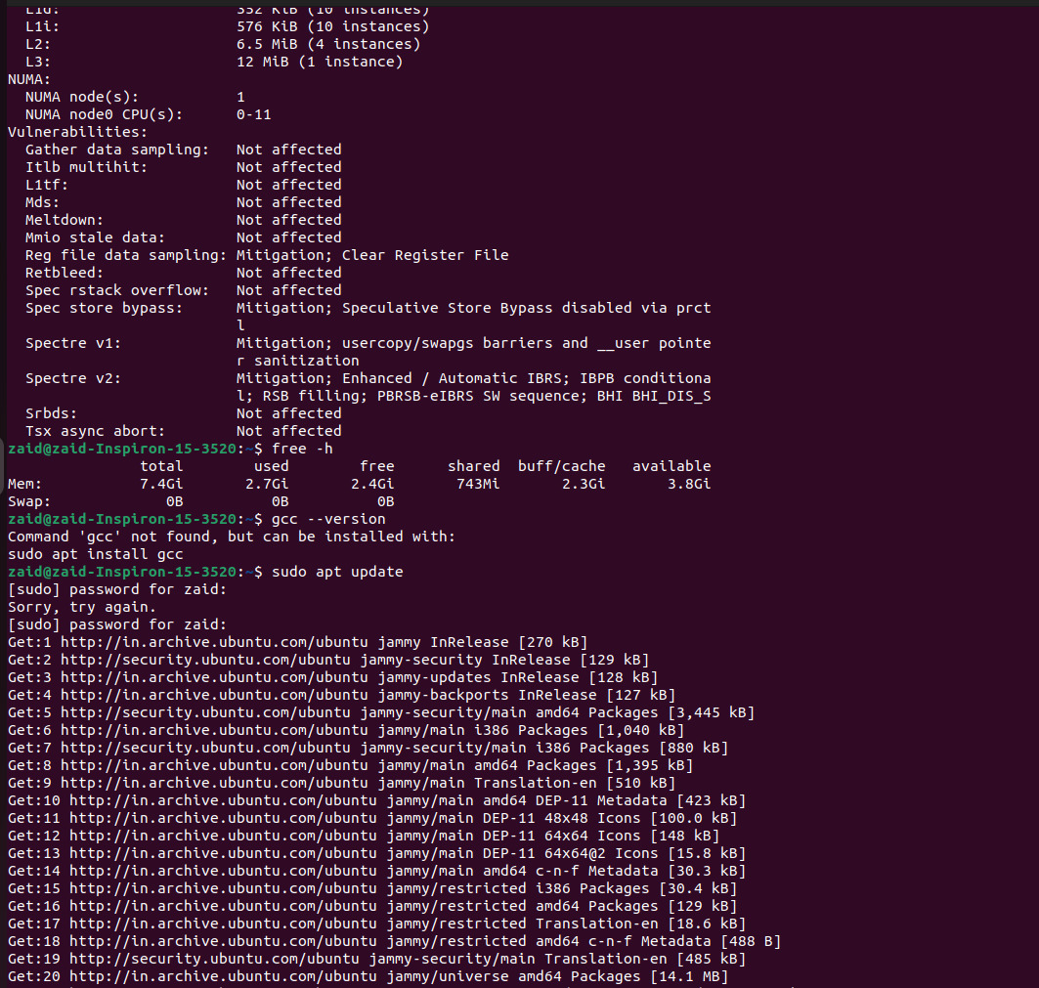
an
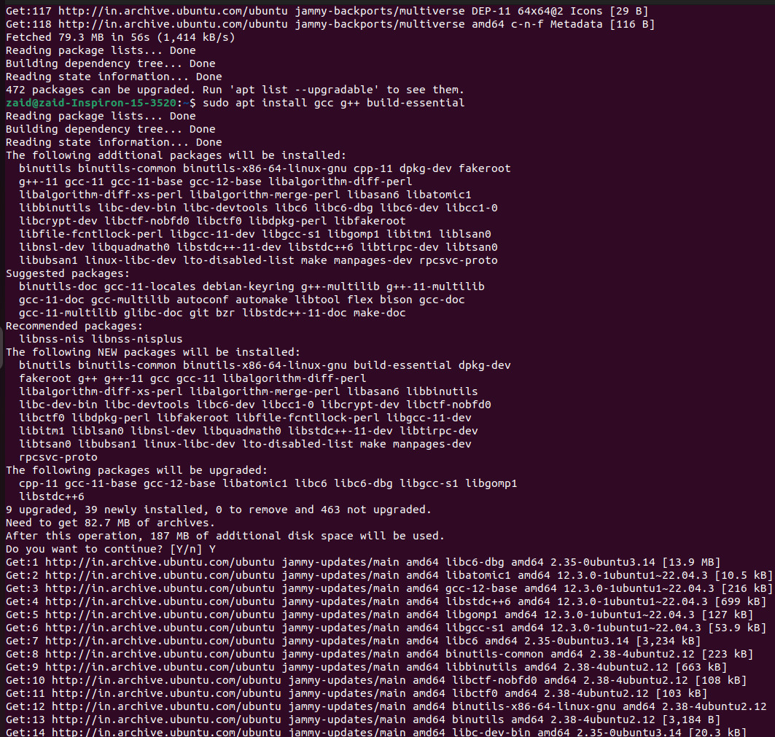
ann
Task 2:
OpenMP Thread Creation & Performance Analysis

Analysis of Results — Why is Speedup < 1?
The experimental results show that the speedup is less than 1 for all tested thread counts. With 2 threads, the speedup is approximately 0.00862×, while it decreases to 0.00079× with 16 threads. This means that the parallel version takes significantly more time than the serial version for this particular workload.
The main reason is the very small problem size. The program performs only 1000 integer-square calculations, which is an extremely small computational workload. The serial execution completes this operation in only a few microseconds, ranging from approximately 1.263 µs to 2.564 µs in the measured runs.
In contrast, the parallel version introduces additional OpenMP overhead. Creating and managing multiple threads, scheduling the loop iterations, synchronizing threads, and entering and leaving the parallel region require additional execution time. The measured parallel execution time increases from approximately 0.295 ms with 2 threads to 1.597 ms with 16 threads.
Another important factor is the console output inside the parallel region. Each thread prints its thread ID, which introduces I/O overhead and requires coordination between threads. This overhead is much larger than the actual computation of 1000 squares.
The results also demonstrate the practical effect of Amdahl's Law. Parallelization is beneficial when the computational workload is sufficiently large compared with the overhead of creating and managing parallel threads. In this experiment, the actual computation is extremely small, so the parallel overhead dominates the execution time.
The experiment demonstrates that parallelization does not always result in performance improvement. For the very small workload of 1000 square calculations, the computational work is too small to justify OpenMP thread creation, scheduling, synchronization, and I/O overhead. Consequently, the parallel execution time is much higher than the serial execution time and the calculated speedup remains below 1. Increasing the number of threads from 2 to 16 further increases the overhead, resulting in progressively lower speedup. For larger computational workloads, the benefits of parallel execution would become more significant.

Threads | Serial Time (s) | Parallel Time (s) | Speedup
2 | 2.546 × 10⁻⁶ | 2.9535 × 10⁻⁴ | 0.00862×
4 | 2.564 × 10⁻⁶ | 4.39209 × 10⁻⁴ | 0.00584×
8 | 1.686 × 10⁻⁶ | 6.62712 × 10⁻⁴ | 0.00254×
16 | 1.263 × 10⁻⁶ | 1.59706 × 10⁻³ | 0.00079×

Screenshot :
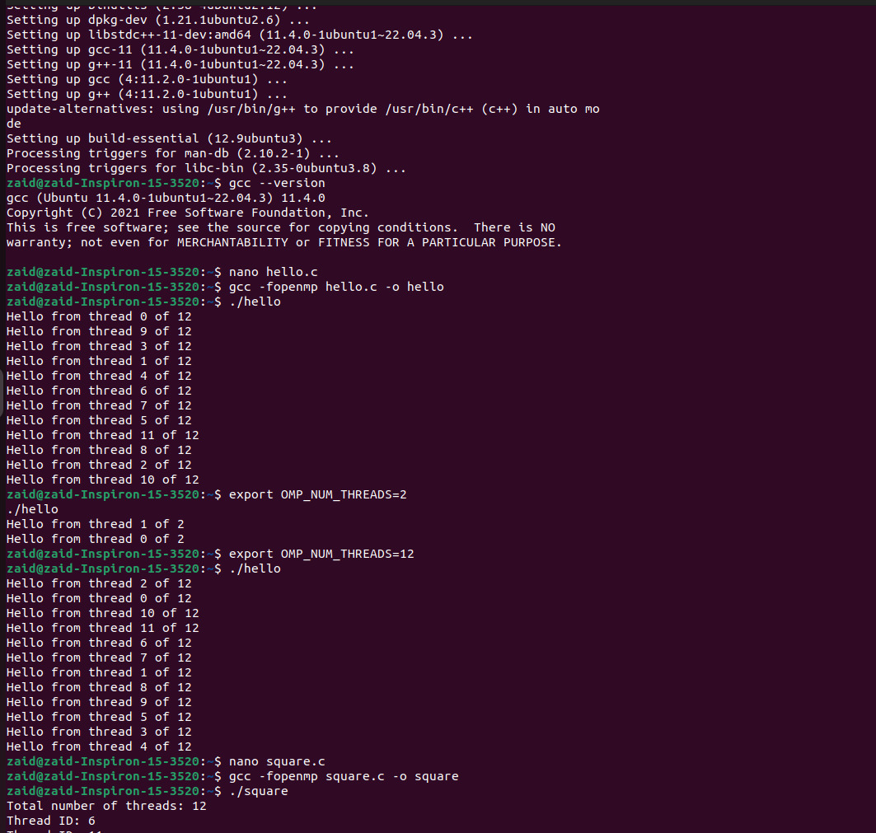
an
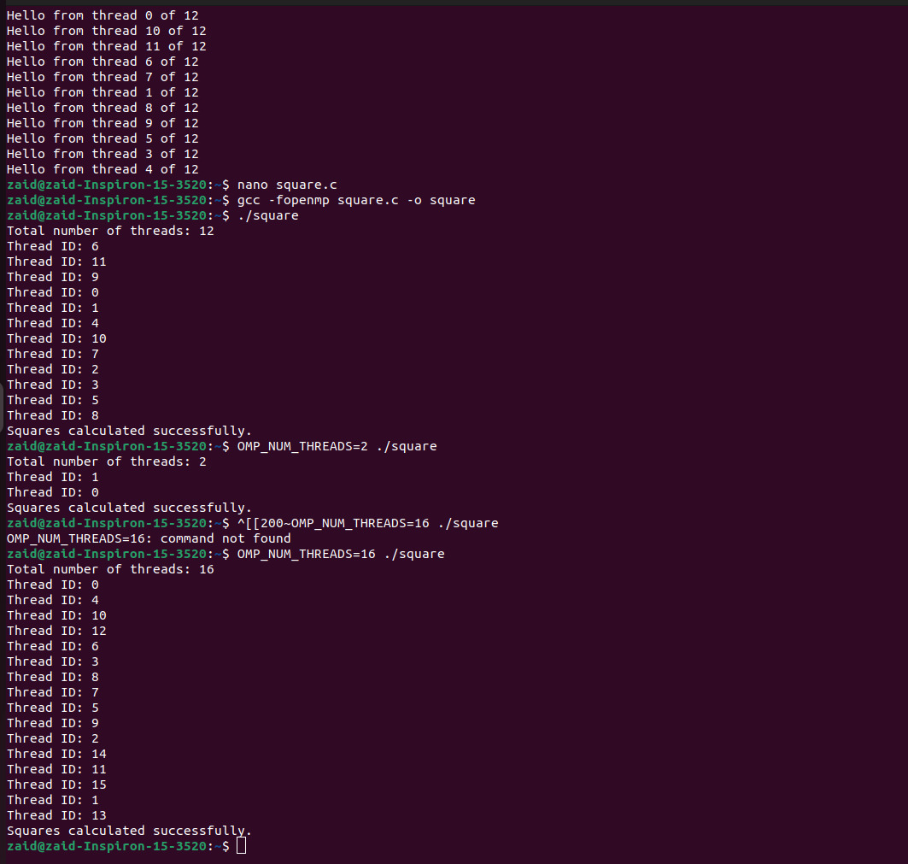

Task 3:

Peak FLOPS of CPU
Processor: Intel Core i5-1235U
CPU Specifications:
Parameter | Value
Physical Cores | 10
P-Cores | 2
E-Cores | 8
Maximum P-Core Frequency | 4.40 GHz
Maximum E-Core Frequency | 3.30 GHz
SIMD Instruction Set | AVX2
SIMD Width | 256 bits
Single Precision Data Size | 32 bits
SIMD Elements | 256 / 32 = 8
FMA Operations | 2 FLOPs

Formula
Peak FLOPS = Number of Cores × Frequency × SIMD Width × Operations per Instruction
For AVX2:
SIMD Elements = 256 / 32 = 8
For FMA:
1 FMA = 2 FLOPs
Therefore:
Peak FLOPS = Cores × Frequency × SIMD Elements × 2

Simplified Theoretical Calculation
Using 10 cores and 4.40 GHz:
Peak FLOPS = 10 × 4.40 × 10^9 × 8 × 2
Peak FLOPS = 704 × 10^9 FLOPS
Peak FLOPS = 704 GFLOPS

Hybrid-Core Adjusted Calculation
The Intel Core i5-1235U contains 2 P-cores and 8 E-cores, which have different maximum frequencies.
P-Core Performance:
P-Core FLOPS = 2 × 4.40 × 10^9 × 8 × 2
P-Core FLOPS = 140.8 GFLOPS
E-Core Performance:
E-Core FLOPS = 8 × 3.30 × 10^9 × 8 × 2
E-Core FLOPS = 422.4 GFLOPS
Total Theoretical Peak:
Total FLOPS = 140.8 + 422.4
Total FLOPS = 563.2 GFLOPS

Final Comparison
Calculation | Peak Performance
Simplified calculation using 10 cores × 4.40 GHz | 704 GFLOPS
Hybrid-core adjusted calculation | 563.2 GFLOPS

Conclusion
The theoretical peak performance of the Intel Core i5-1235U is approximately 563.2 GFLOPS when the different frequencies of the P-cores and E-cores are considered. Using the simplified formula provided in the HPC laboratory assignment gives 704 GFLOPS. The hybrid-core adjusted value is more realistic because the processor contains two different types of CPU cores operating at different maximum frequencies.
The Intel Core i5-1235U has 10 physical cores consisting of 2 P-cores and 8 E-cores. It supports AVX2, which provides a 256-bit SIMD width, corresponding to eight single-precision floating-point values per instruction. Assuming FMA, each SIMD instruction performs 16 FLOPs. Using the simplified formula specified in the experiment, 10 × 4.4 GHz × 8 × 2 gives a theoretical peak of 704 GFLOPS. However, because the processor uses a hybrid architecture, using the specified maximum frequencies of 4.4 GHz for the two P-cores and 3.3 GHz for the eight E-cores gives a more realistic theoretical estimate of approximately 563.2 GFLOPS.

